**Unique Faces and Object Identification**

Table of Contents

[1 The Problem 2](https://docs.google.com/document/d/1s7xQsOE4LJG79HbH9pTsB3BhTSF4fZMMVICP5Vh25xk/edit#heading=h.gjdgxs)

[2 The Solution 2](https://docs.google.com/document/d/1s7xQsOE4LJG79HbH9pTsB3BhTSF4fZMMVICP5Vh25xk/edit#heading=h.30j0zll)

[3 Solution Architecture 2](https://docs.google.com/document/d/1s7xQsOE4LJG79HbH9pTsB3BhTSF4fZMMVICP5Vh25xk/edit#heading=h.1fob9te)

[4 Methodology 2](https://docs.google.com/document/d/1s7xQsOE4LJG79HbH9pTsB3BhTSF4fZMMVICP5Vh25xk/edit#heading=h.3znysh7)

[5 References 2](https://docs.google.com/document/d/1s7xQsOE4LJG79HbH9pTsB3BhTSF4fZMMVICP5Vh25xk/edit#heading=h.2et92p0)

## **1. The Problem**

The need for comprehensive tools to identify and index unique faces and objects in videos and images is increasingly critical in various sectors. Current solutions often lack efficiency, scalability, or are too costly for continuous processing. Key challenges include:

- Handling large volumes of image/video data.

- Accurately identifying and distinguishing between unique faces and objects.

- Building a scalable system that can process data locally without compromising confidentiality.

- Integrating search capabilities that allow users to retrieve information using face or object references.

## **2. The Solution**

To address these challenges, this project aims to develop a system that:

- Identifies and extracts unique faces and objects from multimedia files.

- Indexes detected data to facilitate fast and efficient searching.

- Utilizes local processing to ensure confidentiality and cost-effectiveness.

- Uses Qdrant for indexing and retrieving search results based on detected faces and objects.

## **3. Solution Architecture**

### **Overview**

The architecture includes:

- **Data Ingestion**: Handling video and image data input via an interface.

- **Preprocessing**: Cleaning and preparing data using OpenCV and custom scripts.

- **Face and Object Detection**: Utilizing dlib and face_recognition libraries.

- **Indexing and Metadata Creation**: Organizing output data with timestamps and location references.

- **Search Integration**: Using Qdrant for fast and effective data retrieval.

- **Wasabi Integration**: Providing seamless data storage and retrieval.

### **Diagram**

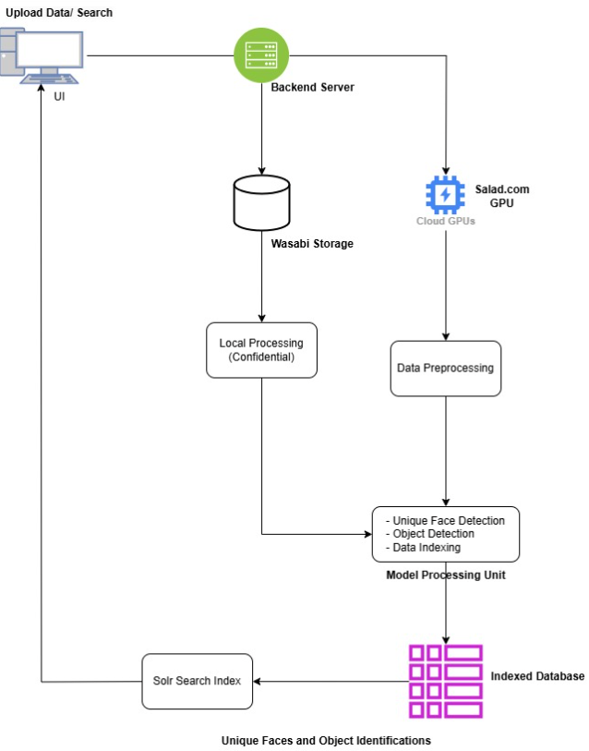

## **4. Methodology**

### **4.1 Planning and Setup**

* **Requirement Gathering**: Reviewed initial code and identified necessary adjustments.
* **Infrastructure Preparation**: Configured CUDA and GPU environments; integrated Salad.com and Wasabi for remote processing and storage.

### **4.2 Data Management**

* Developed interfaces for:
  + **Wasabi**: For data upload and retrieval.

### **4.3 Model Implementation**

* Fine-tuned existing models for:
  + **Face Detection and Recognition**: Leveraged dlib and face_recognition for accurate face extraction.
  + **Object Detection**:Implemented object detection using OpenCV and YOLOv3.

### **4.4 Search and Indexing**

* **Qdrant Integration**:
  + Integrated Qdrant for indexing faces and objects, enabling search by image or object characteristics.
* **Metadata Organization**:
  + Created a system to store metadata with searchable attributes like timestamps and location data.

### **4.5 Testing and Optimization**

* Conducted:
  + **Unit Tests**: Validated individual modules.
  + **Performance Tests**: Ensured efficient processing under various loads with GPU and cloud resources.
* Addressed challenges such as compiling dlib with CUDA for Windows and optimized the code for scalability.

### **4.6 Deployment**

* **Deployment Strategy**:
  + Launched the application for local execution, ensuring ease of use and confidentiality.

## **5. References**

* Wasabi storage service documentation.
* Qdrant vector database integration guide.
* Python libraries: OpenCV, dlib,Retina-face, face_recognition, PyTorch, YOLOv3.

**GitHub Repository**:

* [Greg-Galvin-Unique-Faces-and-Object-Identification](https://github.com/AjayBidyarthy/Greg-Galvin-Unique-Faces-and-Object-Identification/)

**Project Team Contact Information**:

* **Project Lead**: Samit Dhawal
* **Project Team**: Eshwar Adduri, Divakar Singh
* **Email**: [addurieshwar6@gmail.com](mailto:addurieshwar6@gmail.com), [ds299555@gmail.com](mailto:ds299555@gmail.com)